Lab 1 Report
The purpose of this lab is to introduce you to the usage of some important lab equipments. The lab also gives an example circuit to improve your understanding about equipments. This lab will allow you to learn about how to use a Lab Bench Power Supply, a breadboard, a multimeter.
This is a sample lab report for you to get used to. In the following weeks, you will fill in such a report and give it to us for grading.
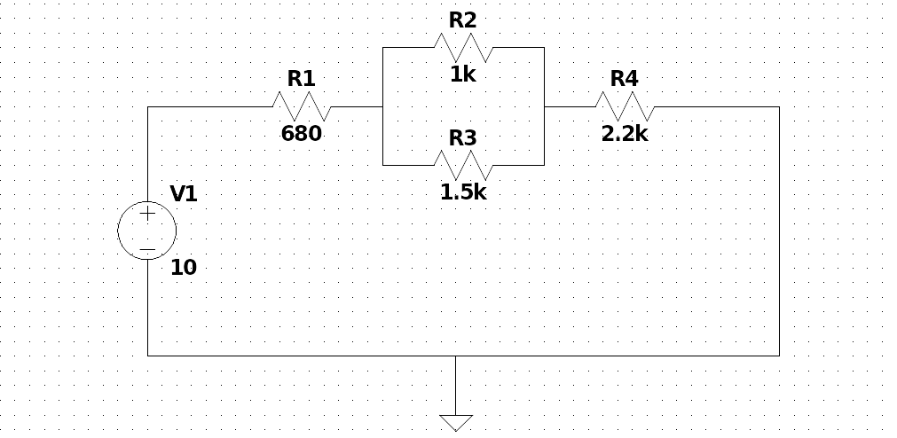Figure 1: The circuit diagram of Experiment 1.

Components and Instruments used:
- A computer: used in the pre-lab to get experiment details from the Moodle
- Resistor kit: contains the resistors to create circuits in the breadboard
- Tektronix PS280 power supply: voltage source
- Fluke multimeter: used to get measurements such as potential difference, current, etc.
- Breadboard: used to create circuits and connect wires to find values

Procedure:
- Create the circuit shown in Figure 1 on breadboard using the shown resistor values.
- Connect the power supply and set it to the 10V of DC voltage.
- Set the multimeter to voltage measurement mode and for each resistor, connect the multimeter as parallel to the resistors and measure the voltage drops.
- Set the multimeter to current measurement mode and for each resistor, connect the multimeter as series before or after to the resistor that you want to measure the current passing through.

Results
Table 1: Voltage measurements.
VARIABLE | CALCULATED | MEASURED | %ERROR
V_{R1}
V_{R2}
V_{R3}
V_{R4}
TOTAL

Table 2: Current measurements.
VARIABLE | CALCULATED | MEASURED | %ERROR
I_{R1}
I_{R2}
I_{R3}
I_{R4}

